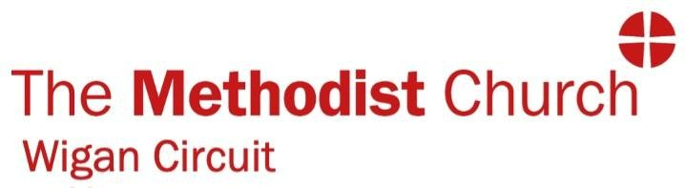
Shape the Future: Circuit Youth Missioner Wigan Methodist Circuit
Are you a trailblazer with a heart for young people and a passion for the Gospel?
The Wigan Methodist Circuit is looking for a dynamic, energetic, and resilient Circuit Youth Missioner to lead a transformation in how we engage with the next generation. This isn't just a "youth work" job—it’s a pioneering mission to foster a culture of discipleship, inclusion, and faith across our community.

The Mission
You will be the driving force behind our youth ministry, balancing the growth of established clubs with the thrill of pioneering brand-new outreach projects. Your mission includes:
- Leading Established Hubs: Bringing high-quality leadership to the Queen’s Hall Church Youth Club and the Aspull Church After School Club.
- Pioneering New Frontiers: Designing and launching fresh strategies for youth work with Rose Bridge and other Churches across the Circuit.
- Creative Discipleship: Planning and leading dynamic programs that help young people explore a personal relationship with Jesus.
- Team Building: Recruiting, inspiring, and training a team of volunteers to create a sustainable, collaborative ministry culture.
- Advocacy: Being the voice for young people within the Circuit, ensuring their gifts and concerns are at the heart of our church life.

Who You Are
- A Committed Disciple: A practicing Christian with a contagious passion for sharing the Gospel.
- A Proven Leader: Significant experience in leading Christian youth ministry.
- Relational & Engaging: A desire to build connections with young people, schools, and the wider community.
- A Self-Starter: You are proactive, organized, and thrive when managing multiple projects across different locations.
- Qualified: Ideally, you hold a recognized qualification in Youth Work or Practical Mission, but not essential.

The Essentials
- Hours: [e.g., 20 hours per week], worked flexibly including evenings some Sundays.
- Salary: [e.g., £16,000 - £18,700 FTE], depending on your experience and qualifications.
- Support: You will work alongside experienced Deacons and Missioners who are already deeply rooted in the community.
- Requirement: Due to the nature of this role, there is an Occupational Requirement for the post-holder to be a committed and practicing Christian. Complete a full enhanced disclosure.

How to Apply
Ready to inspire the next generation in Wigan?
Please submit your application addressing the criteria in the Person Specification to Elaine Meehan wiganmethodist@gmail.com.
Closing Date: Friday, 30th May, 2026
Interview Date: Week beginning 8th June, 2026
This post is subject to a satisfactory Enhanced DBS check and references.

